Dimension Table
Dimension table also known as reference table.
Dimension table contains surrogate key, natural key.
Dimension table are those tables that give textual info about the users.
Uses:- Analysis,Filtering,Cleaning
Features:- Flat structure,de-normalized,verbose,stnd meaning

Fact table
(Fact tables are those table which gives you info about business terms )in lame en language.
fact table also contain dimension table field.
fact table field wont be present in dimension table attributes.

Looking at the following diagram:-

Here fact table also contain dimension tables field .

ProductId

ProductName
dimProductKey
Name
ContactNo
Address
dimCustomerKey
Year
Month
Day
dimDateKey
FactSales
CustomerKey
ProductKey
SalesPrice
SalesQuantity
Date key

Surrogate key:- Anonymous Integer Primary Keys
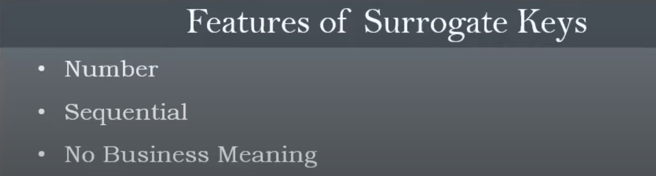
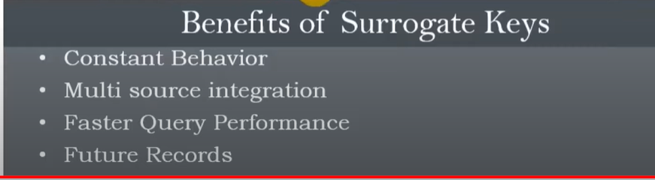
Eg of surrogate key
S.K | StorId* | Store_name | State | City | ZipCode
1 | S1001 | Xyz | Maharastra | Mumbai | 400002
2 | S1002 | Abc | Gujrat | adi | 430015
3 | S1003 | uah | Rajasthan | jaipur | 410050
4 | S1001 | XYZZ | Maharastra | Mumbai | 400002

Store Id is primary key*
*primary key means the column which cannot have null values and its mandatory/imp atrrribute to distinguish among differnets tables.
From above table its clarifies that surrogate key are independent of the data record.
Since S1001 came twice and S.K is not same its impacts that it doesnot affect the dataset.

